Reviewer

Two types of reviewers

1 mandatory

2 Non-mandatory

1 mandatory reviewer

Go to configuration -> workflow designer -> go to workflow type and select project ->SELECT WORKFLOW

GO TO WORKFLOW DETAIL

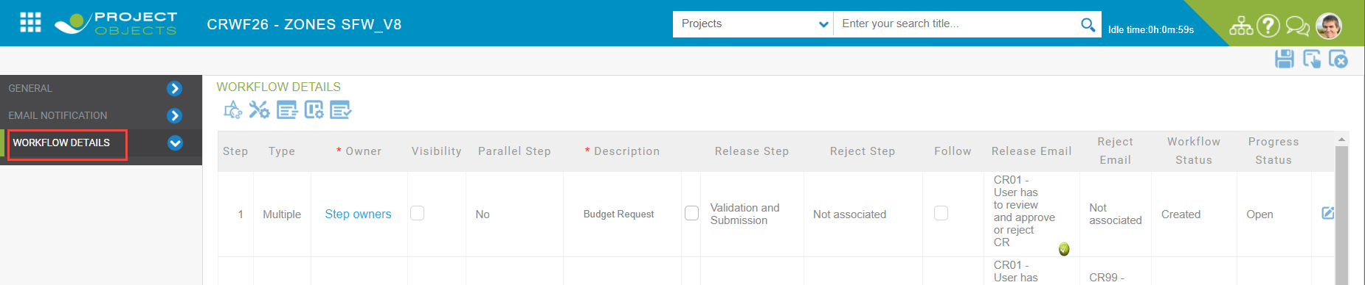

Go to review configuration button

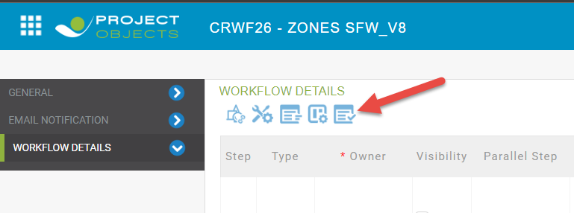

Select the workflow steps and click on add reviewer button and select a user

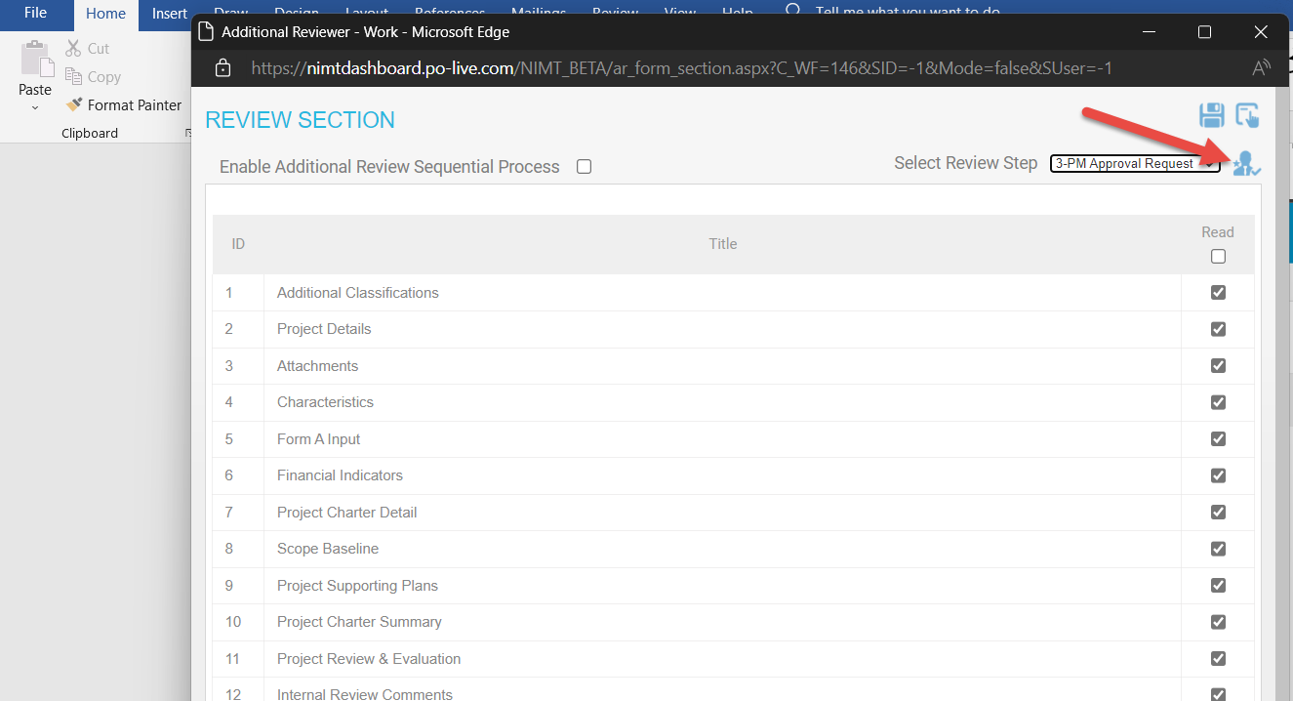

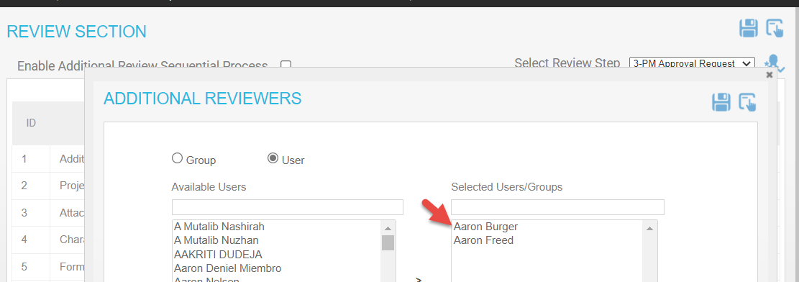

Create a new project and go to release on third step

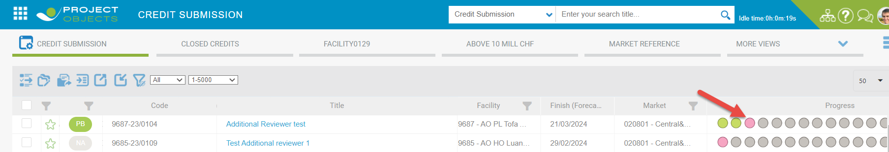

Login to selected user PUBURGERAA

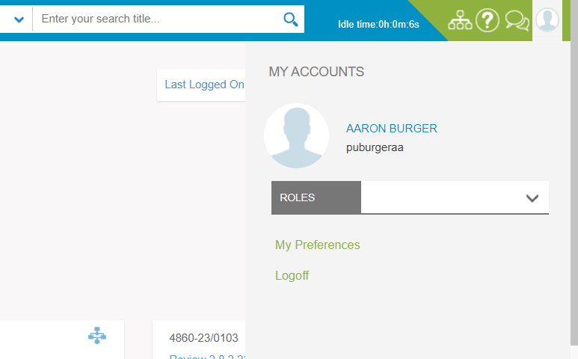

Go to my actions and click current object

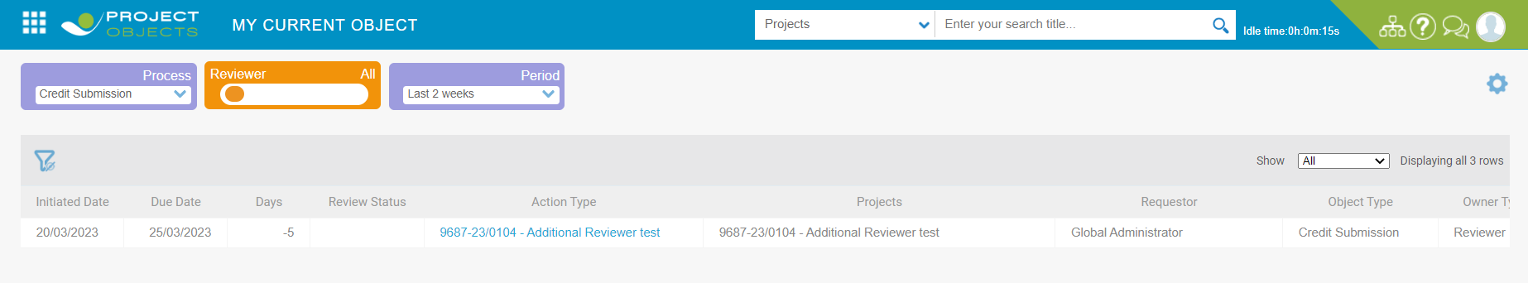

Go to additional reviewer and click on reviewer comment button

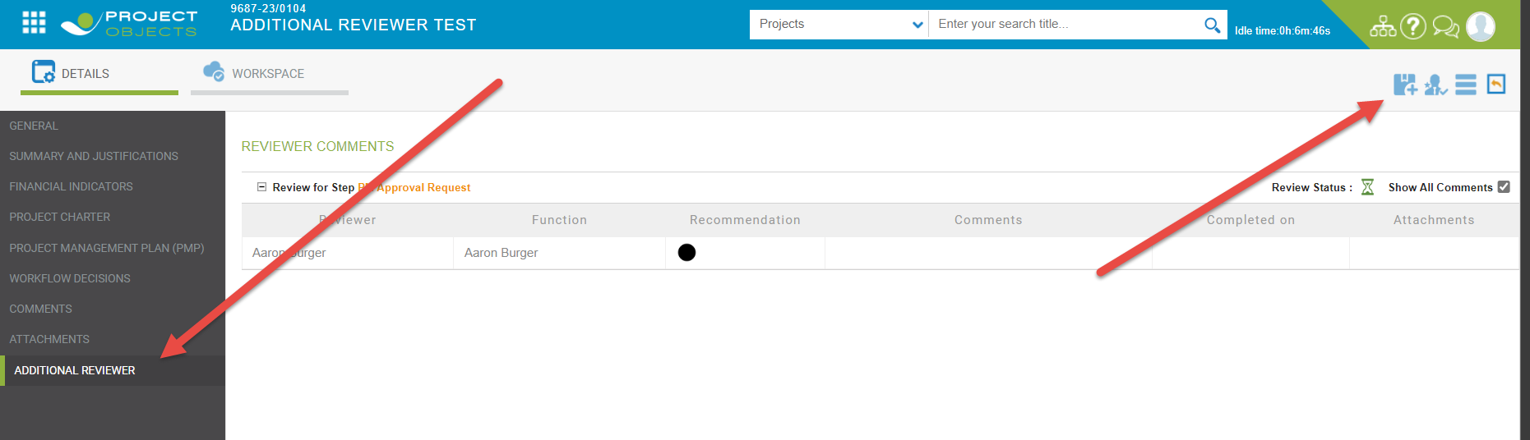

After the reviewer given the reviewer comment and click on save. Reviewer completed by this user

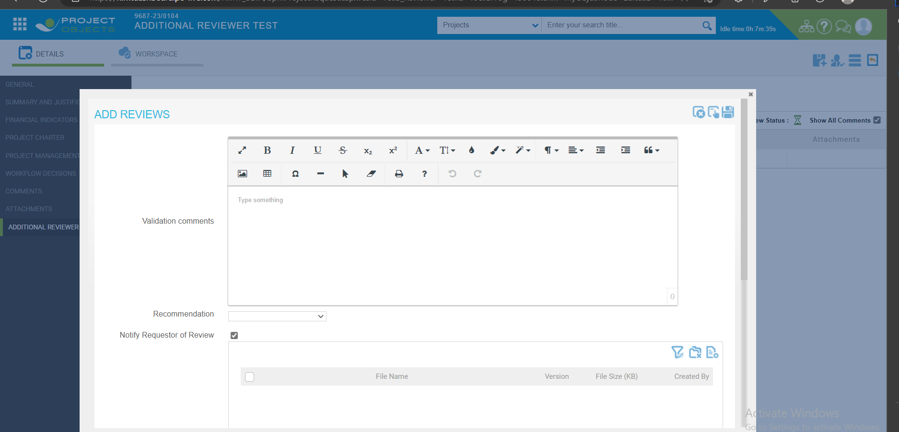

After comment given by reviewer mail notification is goes to object creator

Go to configuration-> email notification

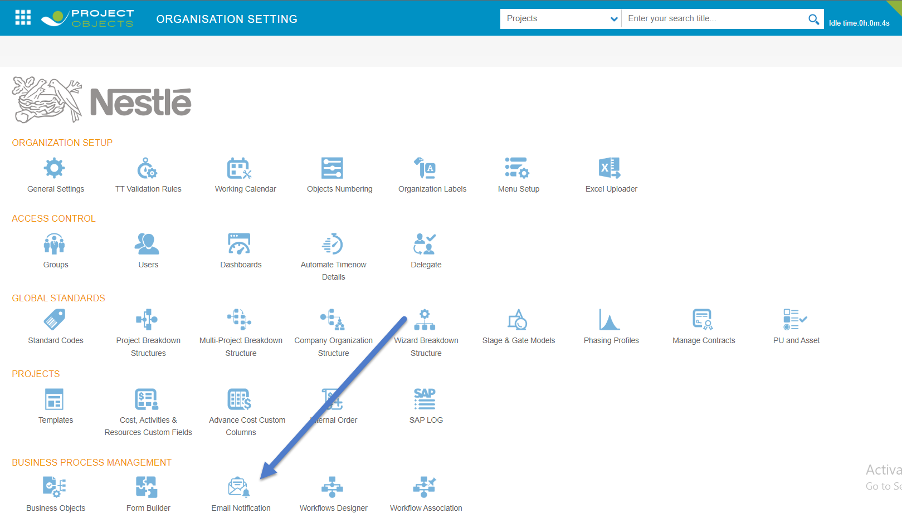

Click on email notification -> go to email log

